FRONT-END PROGRAMMING CSM3103



UNIVERSITI MALAYSIA TERENGGANU

LAB MODULE 1

NAME : ILHAM HANINA MADIHA BINTI OTHMAN

MATRIC NO : S63762

PROGRAMME: BACHELOR OF COMPUTER SCIENCE (MOBILE COMPUTING)

LECTURER : DR RABIEI B MAMAT

Task 1

Output for step 3:

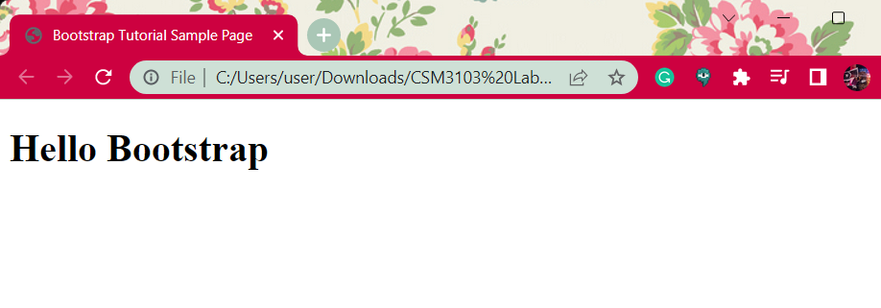

Evaluate the output: -

Output for step 5:

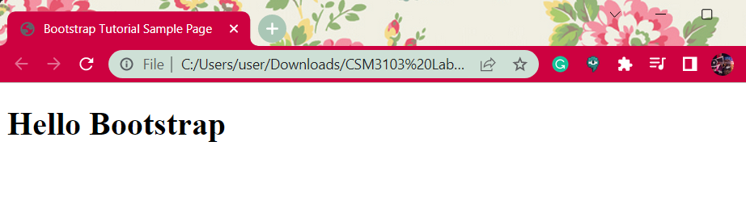

Task 2

3. Open in browser Evaluate your result and compare with Task1(6)

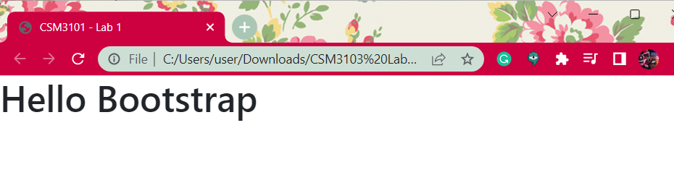

Task 3

3.b. Save and evaluates the result

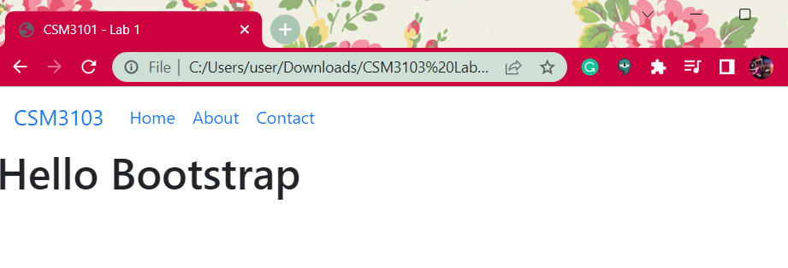

5.c. Add new link refer to main.css in the head section after bootstrap.css link

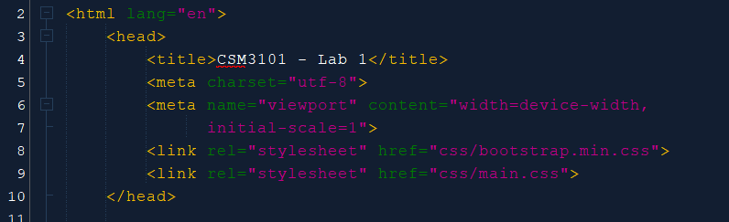

5.d. Save your file and open your file using browser

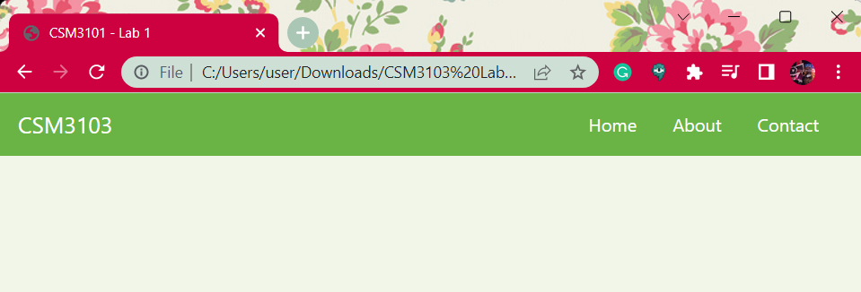

6.i. Evaluate the results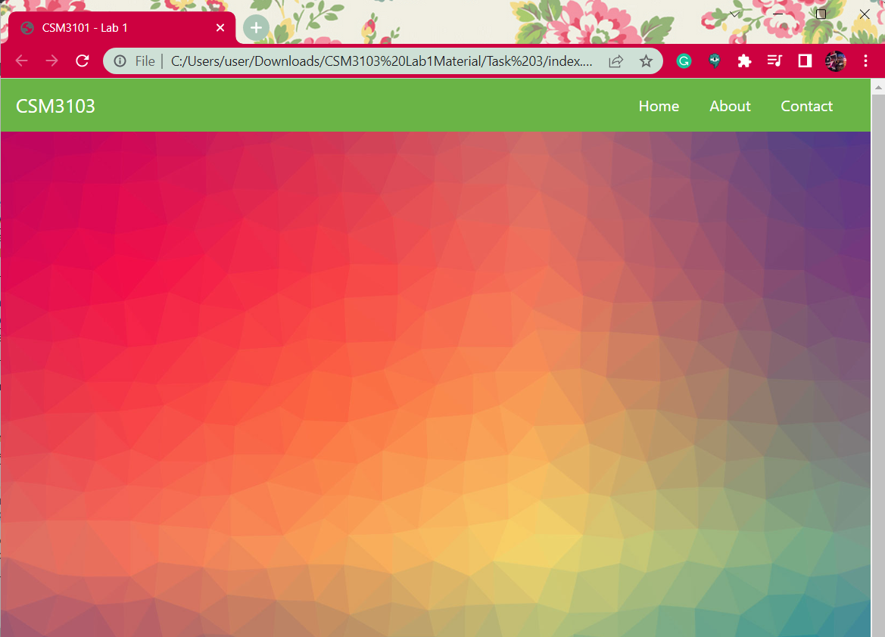

7.b. Save and see the output on the browser

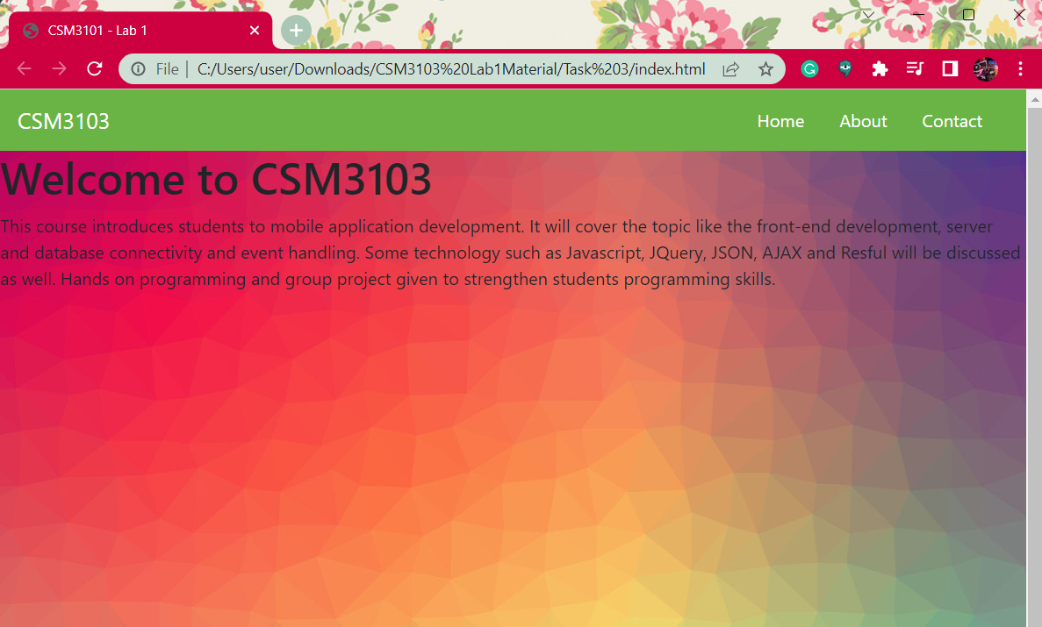

7.c. What do you think about the result?

- not justified.

8.c. Save and evaluate the output

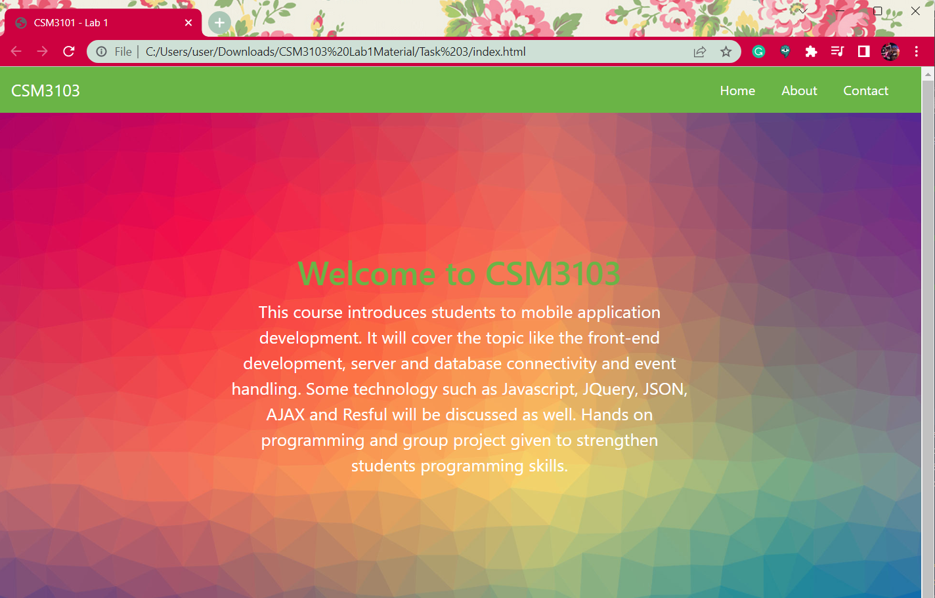

9.d 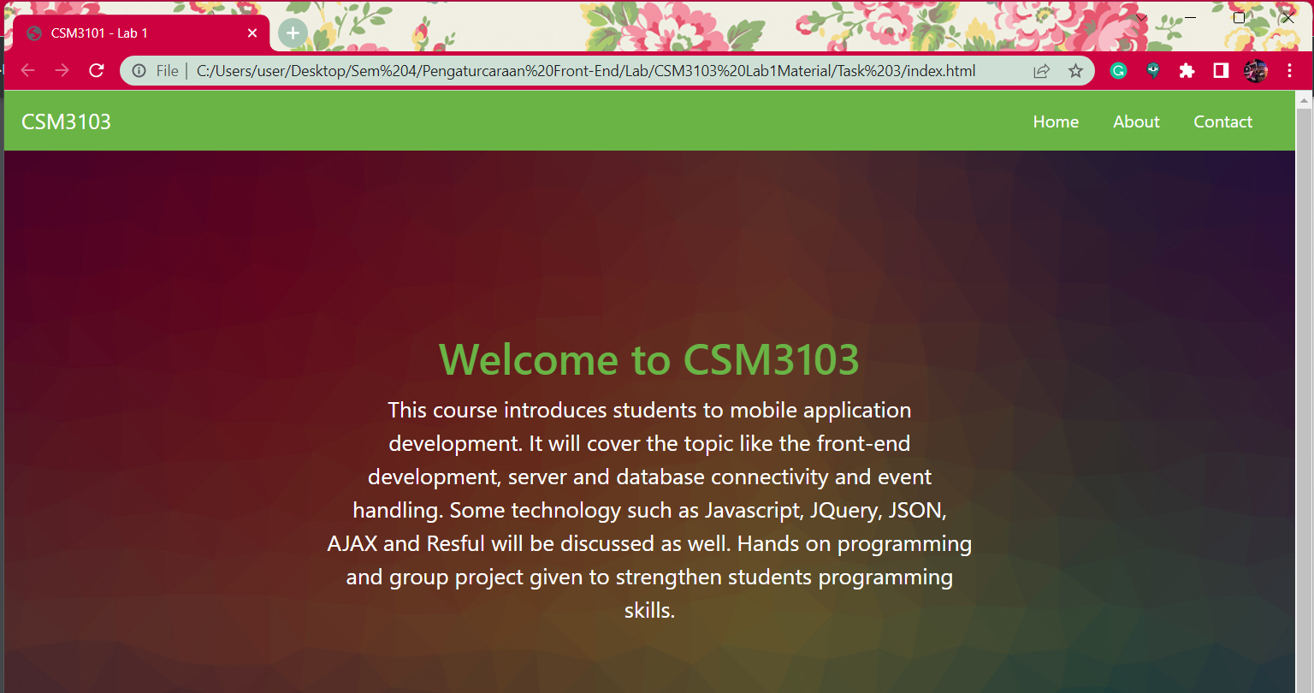

10.b There Is button

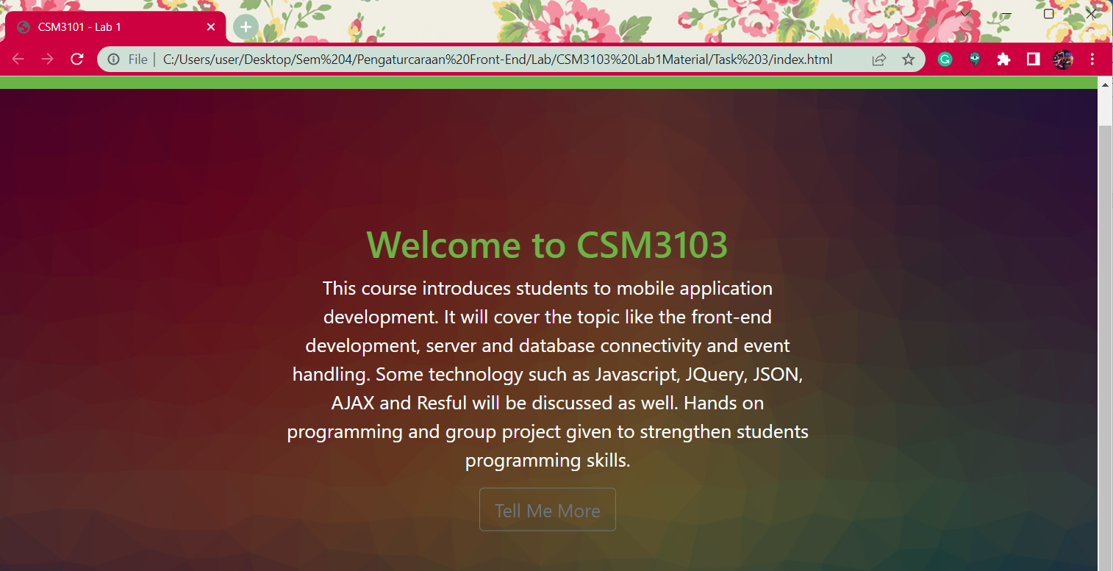

If hover, it become like this: -

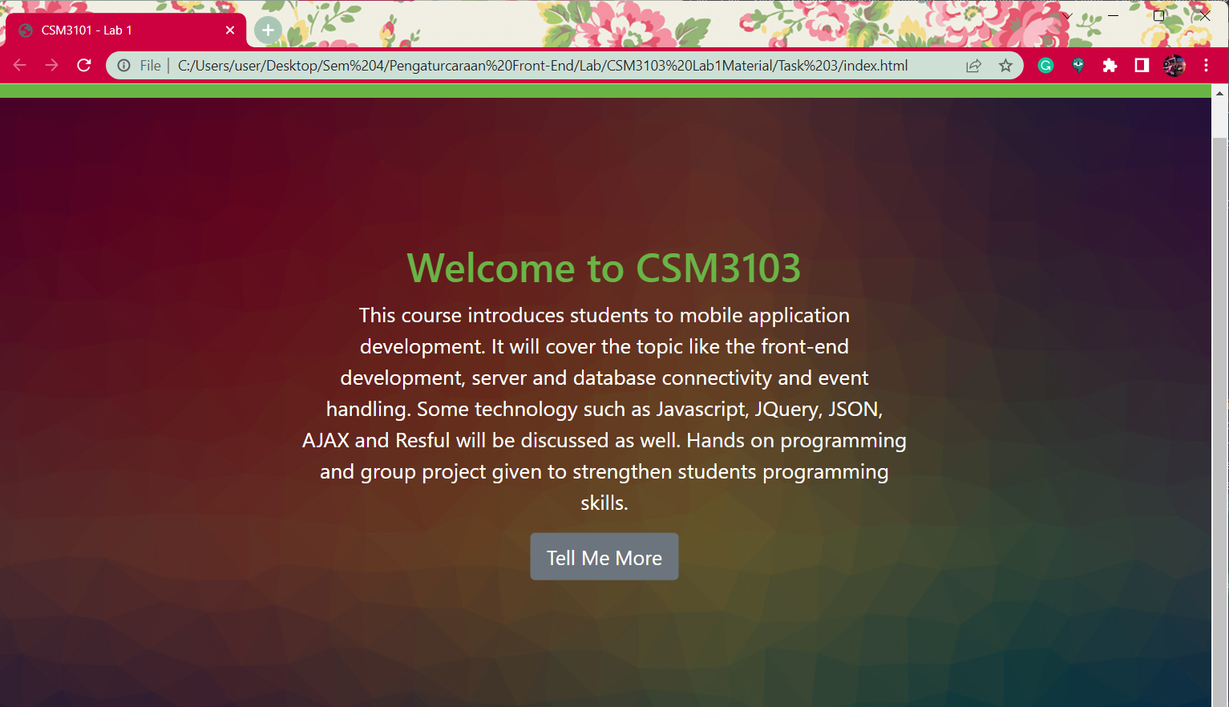

10.d

If it doesn’t touch the cursor, it’ll be like that.

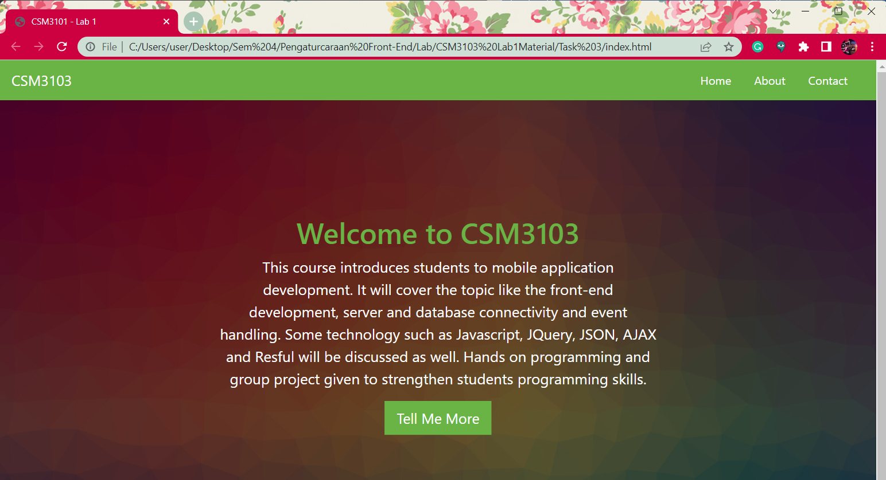

If touch the cursor, it will appear like this: -

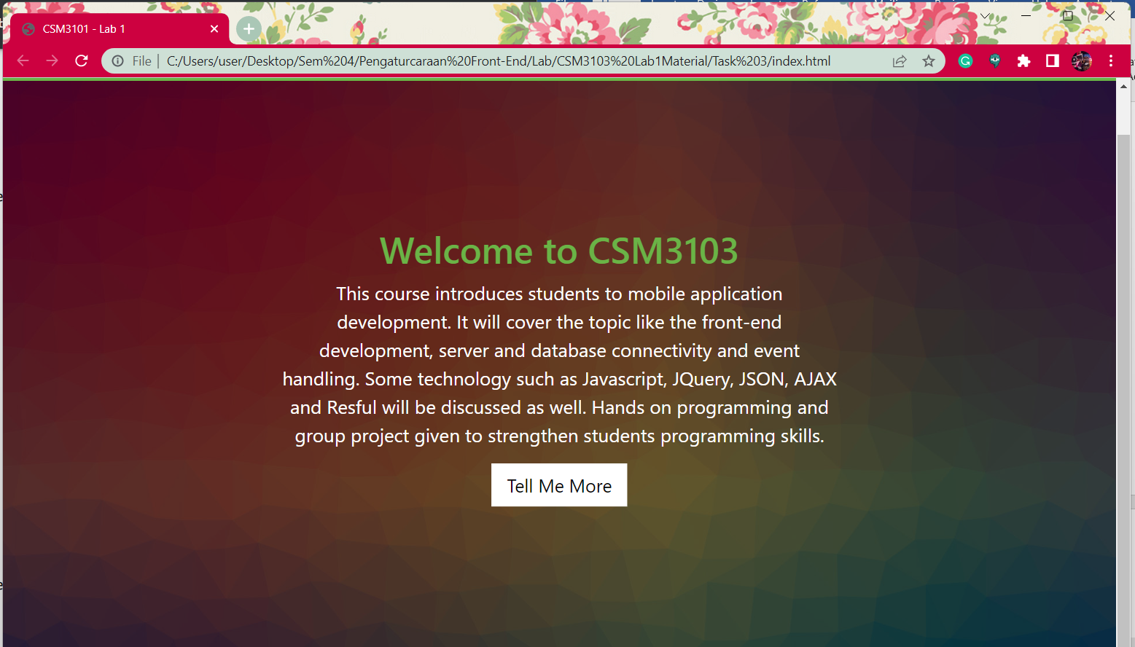

11.c 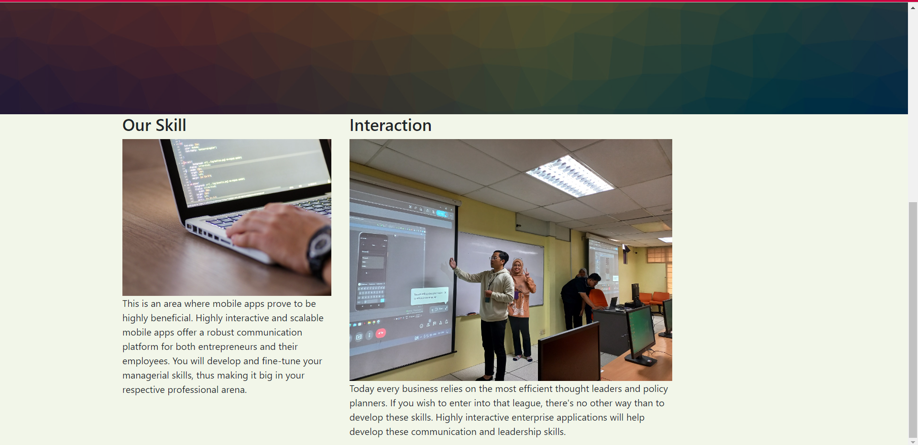

Final output for task 3 after ‘Our Skill’ and ‘Interaction’: -

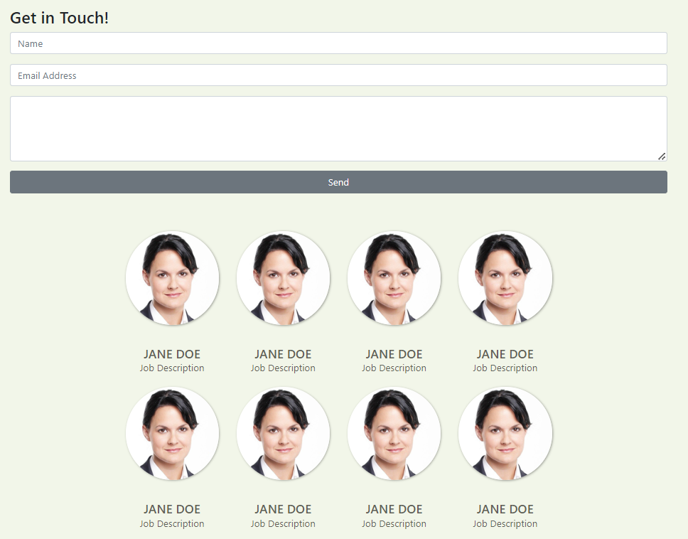

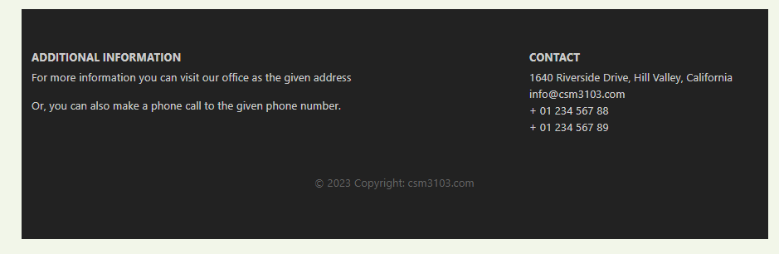

Task 4

Output for task 4: -

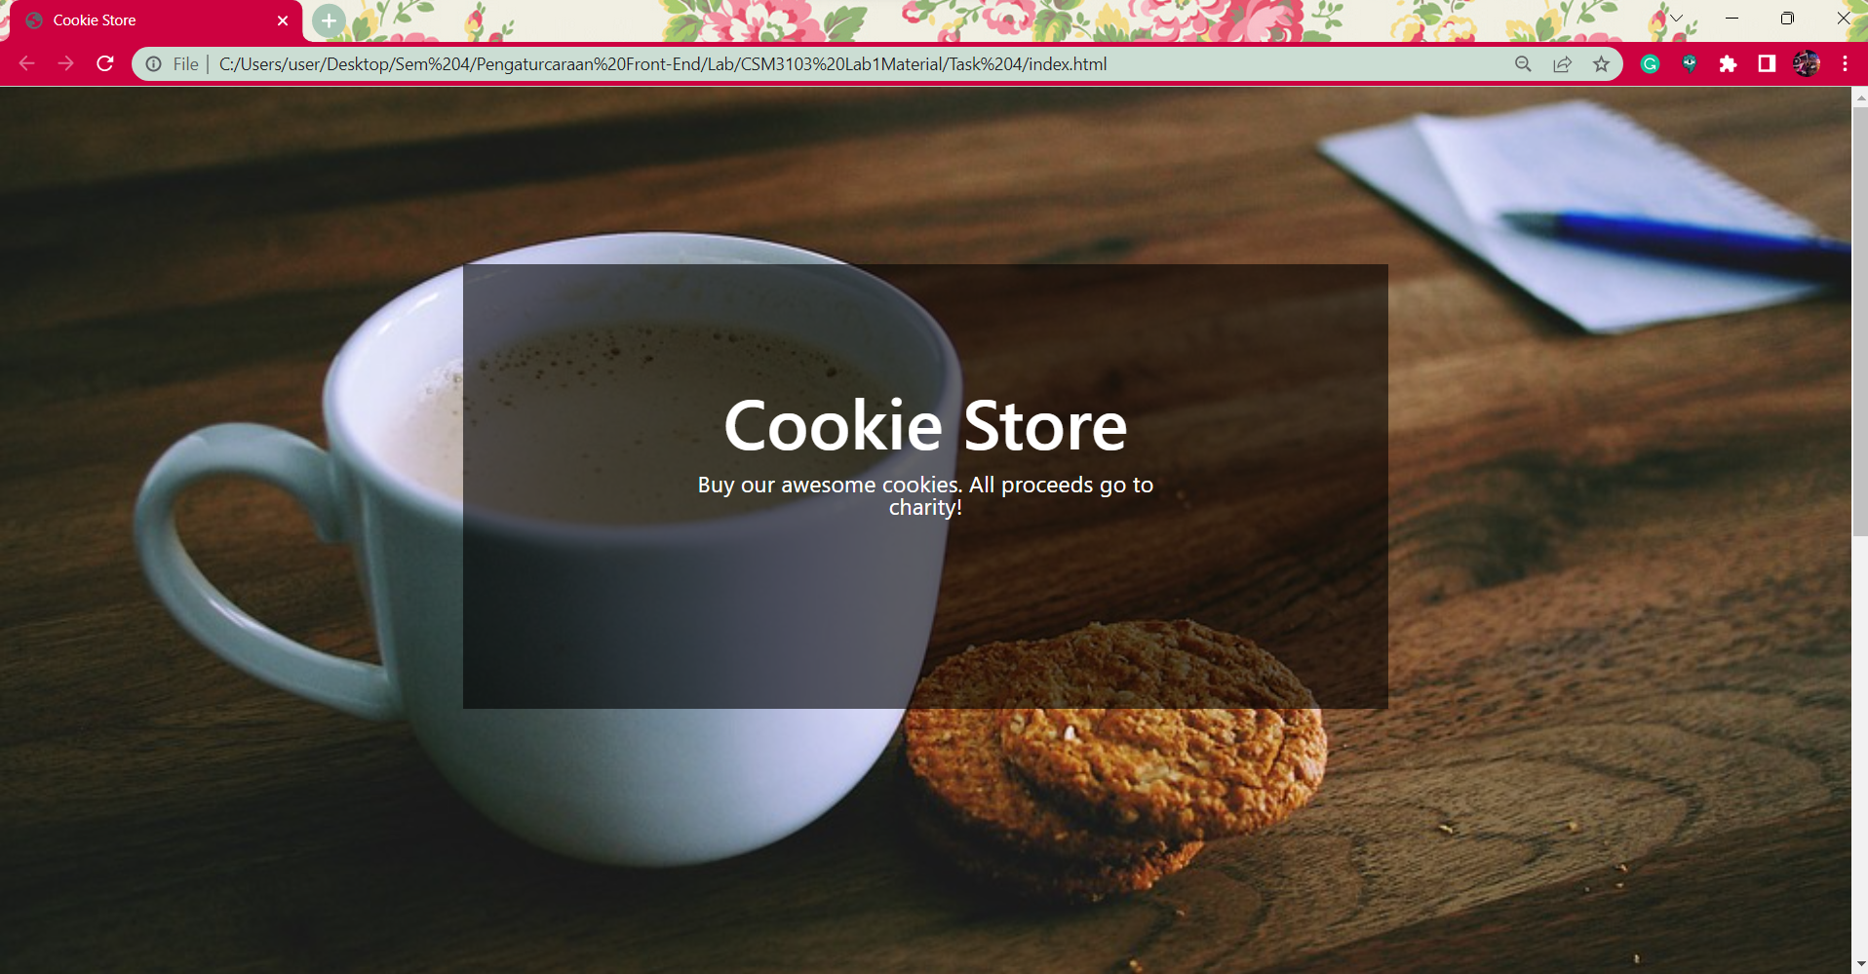

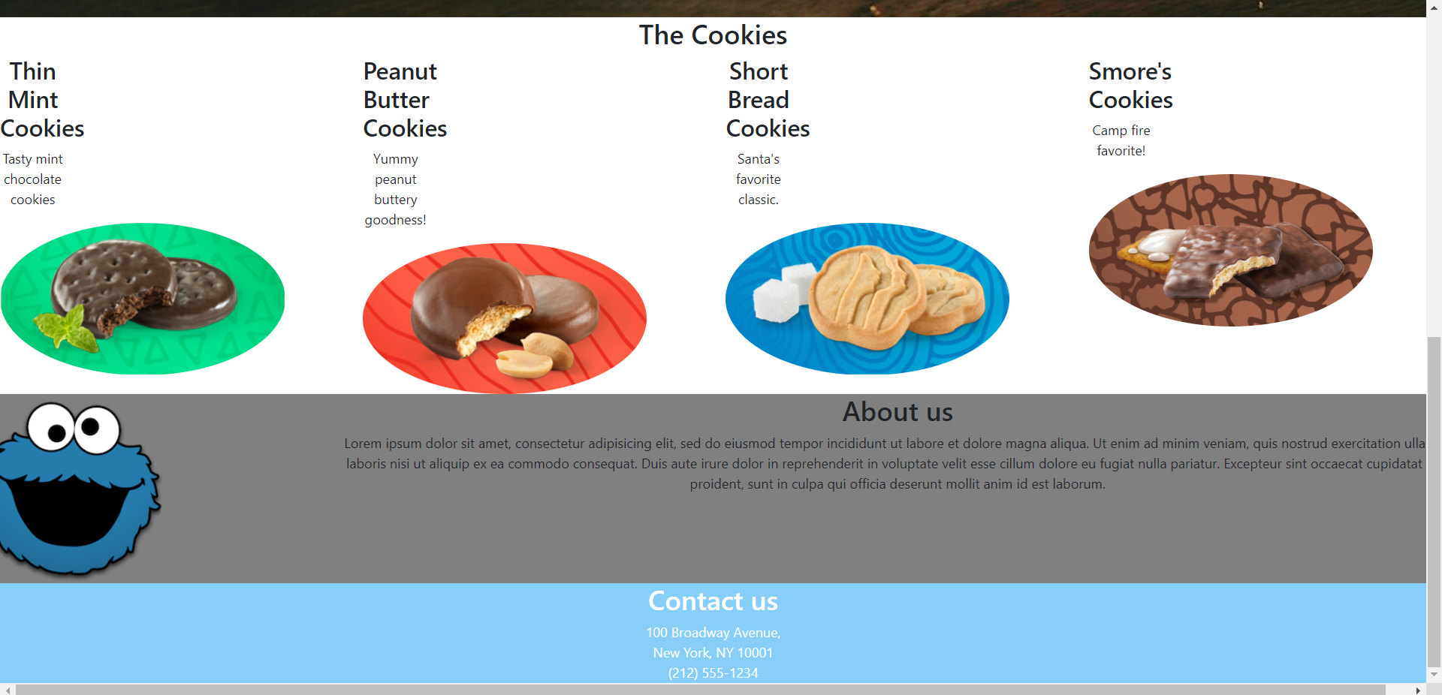

Task 3 and Task 4 github link: - <https://github.com/ilhamhanina/Lab1.git>